|  |  |
| --- | --- |
|  | **Qatar University**  **College of Engineering**  **Department of Computer Science and Engineering** |

Senior Project Report

**ParQU - Parking System Using Cloud Computing Based on IoT**

**Project Group Members:**  
Amal Khaled Haidarah (201302862)

Alaa Mousa Mousa (201305148)  
Ghareisa Mohammed Al-Kuwari (201402464)

**Supervisor**: Dr. Abdulaziz Al-Ali

**2018**

This project report is submitted to the Department of Computer Science and Engineering of Qatar University in partial fulfillment of the requirements of the Senior Project course.

# Declaration

This report has not been submitted for any other degree at this or any other University. It is solely the work of us except where cited in the text or the Acknowledgements page. It describes work carried out by us for the capstone design project. We are aware of the university’s policy on plagiarism and the associated penalties and we declare that this report is the product of our own work.

Student: Amal Khaled Haidarah Date: 25-11-2018

Signature:

Student: Alaa Mousa Mousa Date: 25-11- 2018

Signature:

Student: Ghareisa Mohammed Al-Kuwari Date: 25-11- 2018

Signature:

# Abstract

Qatar University is becoming one of the most crowded places in Qatar, which with time raised a huge parking problem that lead to a chaotic parking experience in the university. Faculty, staff and students started complaining about the negative effects that parking caused, such as not finding a vacant parking spot easily, in turn making them waste time and late for their lectures. In the hopes of solving this issue, we are planning on creating a parking system based on the Internet of Things (IoT) concept. IoT is a network consisting of devices, machines or objects that are able to communicate and transfer data without the need of a human-to-human or human-to-computer interaction.

The system will give the users the ability to reserve a parking spot with the requirement of subscribing into our system. Also, the system gives the service of viewing the availability of a parking spot without the need of a subscription. The parking system involves an Android mobile application, a website and a hardware prototype to be installed in the parking area. The hardware prototype consists of sensors such as Ultrasonic sensor and RFID (Radio Frequency Identification) for car detection and an embedded system to collect data from these sensors and communicate that information to the cloud. The on-board application and website exposes the functionalities of the system along with a cloud database for data storage.

# Acknowledgment

Our project “ParQU - Parking System Using Cloud Computing Based on IoT” gave us a huge amount of experience and knowledge.

First and foremost, we would like to sincerely thank our supervisor Dr. Abdulaziz Al-Ali for his guidance, patience and motivation as well as providing us with the needed comments and suggestions that helped us improve and give our best work.

We would also like to thank our families, friends and colleagues who encouraged us to continue with the project.

Table of Contents

Declaration ii

Abstract iii

Acknowledgment iv

List of Figures vi

List of Tables vii

1. Introduction and Motivation 8

1.1. Problem statement 8

1.2. Project significance 12

1.3. Project objectives 12

2. Background and related work 12

2.1. Background 13

2.2. Related work 13

3. Requirements analysis 20

3.1. Software development process 20

3.2. Functional requirements 22

3.3. Non-functional requirements 24

3.4. Assumptions 25

3.5. Ethics 25

4. Proposed solution 26

4.1. Possible solutions and tradeoffs 26

4.2. Proposed solution overview 28

4.3. Hardware/software to be used 32

5. Project plan 34

5.1. Project milestones 35

5.2. Project timeline 37

5.3. Anticipated risks 45

5.4. Conclusion 45

References 46

Appendix A – Use cases specification 48

Appendix B – Survey Statistics 55

# List of Figures

Figure ‎1‑1: Statistics from Survey 8

Figure ‎1‑2: Article from Al-Sharq Newspaper 9

Figure ‎1‑3: Headline from Al-Raya Newspaper 9

Figure ‎1‑4: Headline from Al-Arab Newspaper 9

Figure ‎1‑5: Headline from Al-Arab Newspaper 9

Figure ‎1‑6: Headline from Al-Arab Newspaper 9

Figure ‎1‑7: Headline from Al-Watan Newspaper 9

Figure ‎1‑8: Tweet from Twitter about the parking problem 9

Figure ‎1‑9: Tweet from Twitter about the parking problem 9

Figure ‎1‑10: Tweet from Twitter about the parking problem 10

Figure ‎1‑11: Tweet from Twitter about the parking problem 10

Figure ‎1‑12: Statistics from Survey 10

Figure ‎1‑13: Vehicles in Qatar University parked illegally 11

Figure ‎1‑14: Vehicles in Qatar University parked illegally 11

Figure ‎2‑1: A Secure Parking Reservation System Using GSM Technology – System architecture 14

Figure ‎2‑2: System Initialization 14

Figure ‎2‑3: Image capture from camera 14

Figure ‎2‑4: Binary image 15

Figure ‎2‑5: Image after Tracing object boundaries 15

Figure ‎2‑6: Detected parking spot 15

Figure ‎2‑7: GUI Display on PC or laptop 16

Figure ‎2‑8: Hardware architecture of the system 16

Figure ‎2‑9: Hardware architecture of the system 17

Figure ‎2‑10: Working process of the system 18

Figure ‎3‑1: Scrum process overview 20

Figure ‎3‑2: Scrum cycle 20

Figure ‎3‑3: Use case diagram 21

Figure ‎4‑1: Statistics from Survey 27

Figure ‎4‑2: Database schema 28

Figure ‎4‑3: NodeMCU model ESP8266 30

Figure ‎4‑4: Ultrasonic sensor - HC-SR04 30

Figure ‎4‑5: Mini Servo - positional rotation 31

Figure ‎4‑6: RFID kit 31

Figure ‎4‑7: 9V to barrel jack adapter 31

Figure ‎4‑8: Full-size breadboard and jumper wires 31

Figure ‎4‑9: Arduino Uno 32

Figure ‎4‑10: Firebase 32

Figure ‎4‑11: Android Studio 32

Figure ‎4‑12: Arduino IDE 32

Figure ‎4‑13: WebStorm 32

# List of Tables

Table ‎2‑1: Related work comparison 19

Table ‎3‑1: Actor type and descriptions 22

Table ‎3‑2: Use cases and descriptions 22

Table ‎3‑3: Technical design constraints 22

Table ‎3‑4: Practical design constraints 23

Table ‎3‑5: Standard types and descriptions 23

Table ‎3‑6: IEEE and ACM code of ethics 24

Table ‎4‑1: Comparison between different sensors 25

Table ‎4‑2: Comparison between Raspberry Pi and Arduino 25

Table ‎4‑3: Comparison between services 26

Table ‎4‑4: Comparison between reservation duration options 26

Table ‎4‑5: Hardware components with descriptions 30

Table ‎4‑6: Software components and descriptions 32

Table ‎5‑1: Milestone Fall 2018 33

Table ‎5‑2: Milestone Spring 2019 34

Table ‎5‑3: Timeline Fall 2018 35

Table ‎5‑4: Timeline Spring 2019 39

Table ‎5‑5: Risks and solutions 42

# Introduction and Motivation

Wherever a person goes in the high population density areas, a parking issue will most likely be present. That is because in this modern world, people tend to have their own vehicles. As the number of cars in the modern world increase, more parking spaces are demanded. There is no difference in the case of Qatar as it is becoming a crowded country and one of those crowded places is Qatar University (QU). The number of students is increasing drastically each year in QU and as Qatar University students, we are motivated to come up with a solution for this problem.

## Problem statement

In Qatar University (QU), there is an ever-increasing number of students annually, which leads to an increase in the number of vehicles arriving at the campus as well. According to the Ministry of Education’s 2012 statistics, the number of students attending QU has exceeded ten thousand students [1] and is only increasing with each passing year, not to mention the number of staff and faculty that also need parking for their vehicles. Today, the number of students in Qatar University has reached more than 20,000 [2]. As a result, there has been a rapid increase in the number of people and their vehicles on campus, and with the limited available parking spaces, parking problems were bound to exist.

Finding a parking space in Qatar University has become a real problem in recent years and has turned into a topic of concern among students and staff of the University. To assess the severity of the parking problem, an online survey was shared with Qatar University students. We will share and explain the results throughout this section. The first question answered by Qatar University students in our survey in Figure 1-1 proves that there is a real problem in finding a vacant parking spot inside the campus.



Figure ‎1‑1: Statistics from Survey

**Local media**

The problem has surpassed the students' conversations to become the talk of the press and media in Qatar. Figures 1-2 up to 1-7, show Qatari newspapers Al-Raya, Al-Watan, Al-Arab and Al-Sharq’s headlines about the parking problem at Qatar University and its impact. The articles highlighted that the effects of this problem were not only limited to students and staff, but also impacted the university’s visiting guests who come for events, ceremonies, seminars or conferences.

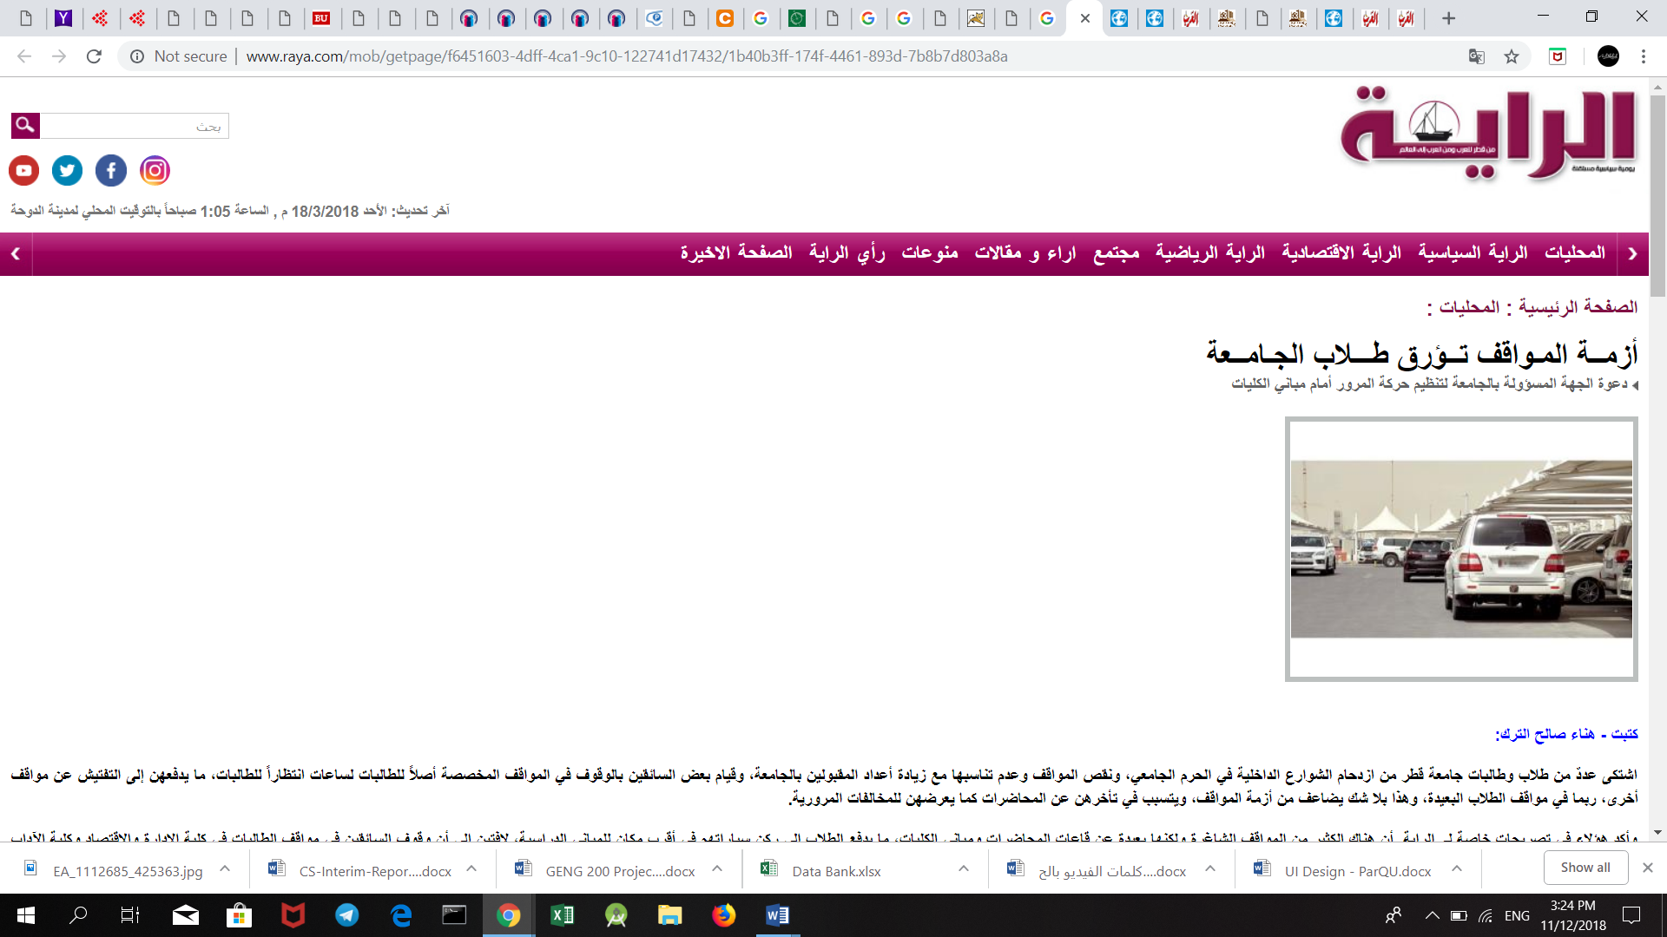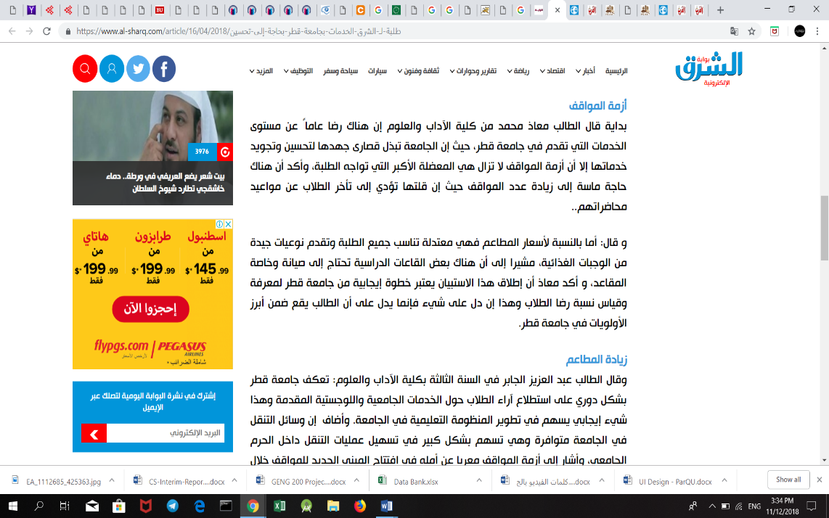

Figure ‎1‑2: Article from Al-Sharq Newspaper

Figure ‎1‑3: Headline from Al-Raya Newspaper



Figure ‎1‑4: Headline from Al-Arab Newspaper

Figure ‎1‑5: Headline from Al-Arab Newspaper





Figure ‎1‑6: Headline from Al-Arab Newspaper

Figure ‎1‑7: Headline from Al-Watan Newspaper

Additionally, frustrated students have taken to social media to air their criticism on the ongoing crisis of parking areas at Qatar University [3]. Students circulated comments, pictures, and videos that represent their daily suffering from the lack of the parking spaces allocated to them in the university.

Tens of sarcastic and critical tweets pointed out this issue as displayed in Figures 1-8 until 1-11 below.



Figure ‎1‑8: Tweet from Twitter about the parking problem

Figure ‎1‑9: Tweet from Twitter about the parking problem







Figure ‎1‑10: Tweet from Twitter about the parking problem

Figure ‎1‑11: Tweet from Twitter about the parking problem

**Impact**

People looking for an empty parking spot is one of the major causes of congestion and a waste to the university attendants’ valuable time. As shown in Figure 1-12, more than 60% percent of the students who responded to our survey reported that they take more than 15 minutes just to find a vacant parking spot. Furthermore, the parking problem causes more fuel to be consumed while driving around parking lots. The increase in fuel consumption wastes the vehicle owner’s money and leads to more CO2 emissions.



Figure ‎1‑12: Statistics from Survey

According to an article in Al-Watan newspaper [4], a number of Qatar University students complained about the university’s lack of balance between the increase number of students’ admissions and the limited number of parking areas. This makes the students to spend more time searching for a vacant parking slot and arrive late to their lectures. A considerable number of students also declared that they are forced to come to the university early, so they can get a parking slot for their cars [5].

Additionally, frustrated drivers are forced to park in illegal parking places which in turn leads to an increase in the number of traffic violations and accidents inside the campus. Figures 1-13 and 1-14 below show examples of illegal parking where cars are parked over sidewalks and on the grass field.



Figure ‎1‑13: Vehicles in Qatar University parked illegally

Figure ‎1‑14: Vehicles in Qatar University parked illegally

In the end, the university’s reputation is negatively affected with the crisis of parking areas, because it is the first thing that guests see when visiting, and to students and staff the way they start their day. If the parking situation continues to be the same, it would hugely impact the image of the university in people’s minds.

**Technical challenges**

The technical challenge we think we will face doing our project:

Ultrasonic sensors might not detect a car if it is not close enough.

More financial and physical resources will be required to scale the system.

1. Internet connection heavily affects keeping the system in real time

Keeping up to date with the latest Android version.

Developing a scalable and extendable, user-friendly application with high level of performance and services.

## Project significance

Based on the above section, additional parking spaces are desperately needed on campus. If there are proper parking places, then traffic problems in Qatar University would be less apparent.

However, even with limited parking spaces, a parking system is needed to organize and utilize the parking area resources. The parking system can also guide the vehicle owners at the university to reduce traffic overcrowdings by suggesting different routes at the campus roads. The system is made more efficient as vehicle owner’s search time is significantly reduced due to the information provided by the smart parking system. This also means that the traffic congestion can be significantly reduced, and the university could even charge vehicle owners when they park illegally.

A smart parking system will not only be beneficial for Qatar University’ attendants, but also is considered valuable for the car parking operators and customers as well as the environment [6][7]. For the parking operators, the data gathered via the implementation of the parking system can be used to predict future parking patterns. Pricing strategies can also be manipulated based on the information gained to increase the university’s profit. In terms of environment protection, the level of pollution can be reduced by decreasing cars emission in the air [6].

## Project objectives

1. To design and implement a system that can manage parking areas.
2. To use Ultrasonic Sensor and RFID Reader to collect data.
3. To use Arduino to receive data from used sensors and send it to the Firebase for storage.
4. To design an Android application and a website.

# Background and related work

In this section, we introduce the parking problem background and some related existing solutions that aim to organize the parking spaces

## Background

No one can deny that parking related problems is a major concern in most of the modern cities worldwide, especially so in Qatar.

Finding a parking spot may seem like a superficial problem, or an individual problem, but it is in fact a problem that causes major issues in our day to day life. In metropolitan areas worldwide, having a parking area is increasingly important and in order to accommodate the growing demand for parking spaces a significant amount of land and buildings are set aside. For instance, in Australia, parking areas hold great importance especially in Brisbane, Sydney and Melbourne where they have a huge number of parking spaces ranging from 25,633 to 41,687 [8]. Furthermore, estimates show that around 30,000 square kilometers of land in Europe and 27,000 square kilometers in the US are devoted to parking spaces [9].

In addition, parking can be very time consuming and costly. This comes as no surprise, “The U.S. economy bears the brunt of parking pain as 40% of drivers say they have avoided driving to shops due to parking challenges.” [10]. According to a study from car service company Inrix, Americans spend an average of 17 hours per year searching for a vacant parking spot, this leads to a loss of $345 per driver in wasted time and fuel. Similarly, drivers in UK spend an average of 44 hours a year looking for an empty parking, with an estimated total loss of £733.

Contrary to the popular belief that generous parking allocations benefits users, the opposite can happen when there’s an exaggeration in parking allocations. A big parking lot prolongs transportation time and is a waste of useable land. These effects -along with recent land-use, socioeconomic and technological trends- are prompting towns to begin asking some important questions about how to solve the parking problem in a smart and cost-effective way.

For this reason, there have been many attempts to provide smart parking systems as a solution, with each having its own different approach as shown in the Related Work section. The used components in the related works varies and can include Ultrasonic sensors, Infrared sensors, and cameras for vehicle detection. The components above help in providing services to the user such as reserving or checking the availability of a parking spot.

## Related work

We will present several studies and the previous literature related to our project which will help us in developing our own design and implementation in further stages. These studies illustrate some of the existing hardware and software solutions to design a parking system.

**A Secure Parking Reservation System Using GSM Technology**

[11] have used GSM technology to propose a secure and smart reservation system for parking areas. The system consists of two major modules which are security reservation module and parking lot monitoring.

Secure Reservation Module

The main idea is that the user has to send SMS message using GSM (Global System for Mobile communications**)** to a Visual Basic application in a laptop/PC. The VB then processes the requested data and checks the available spot. They used the available APIs in VB to process SMS messages. If the requested parking lot is available, the user will receive a confirmation message that has the location for the spot and password. Otherwise, it will receive a reject message.

Parking Lot Monitoring Module

The major aim of this module is to show the status of the parking spots using Parking Layout Animation program through Visual Basic application in a laptop/PC. Their program displays the status of each parking spot through colors. Green color for *empty,* yellow color for *reserved,* and red color for *occupied*. Initially the status of all parking spots are initialized as *empty*. The status will change to *reserved* if the user successfully reserves a parking spot. When the user arrives to the entrance gate, he enters the password then this password will be verified by the controller. If the password is valid, the gate will be opened, and the Parking Layout module will update the spot status to *occupied*.

By using this approach, the user will be charged by telecommunication company in order to send SMS messages. Also, GSM is prone to be easily congested in crowded areas [12]. In their approach, all information is stored locally on one computer which is inefficient as the computer memory will eventually be full and not able to store any more information from the system. Also, if the computer is somehow damaged, all the data will be lost.

Figure ‎2‑1: A Secure Parking Reservation System Using GSM Technology – System architecture

**Intelligent Parking Space Detection System Based on Image Processing**

[13] used image processing technique to detect if the parking lot is empty or not. The proposed solution is carried out in 5 steps as follows:

1- System Initialization:

At the beginning a rounded brown image will be drawn at each parking manually. The benefit of this step is to determine the position of all parking spots in the image.

Figure ‎2‑2: System Initialization

2- Image Acquisition:

The camera will capture image for car park scene and send it to the processing unit that runs in MATLAB program. This step is known as image acquisition.

Figure ‎2‑3: Image capture from camera

3- Image Segmentation:

In the step RGB Image will be converted to grey scale image. Then applying thresholding technique on grey scale image to create the binary image. this technique is helping in separate the objects from the background.

Figure ‎2‑4: Binary image

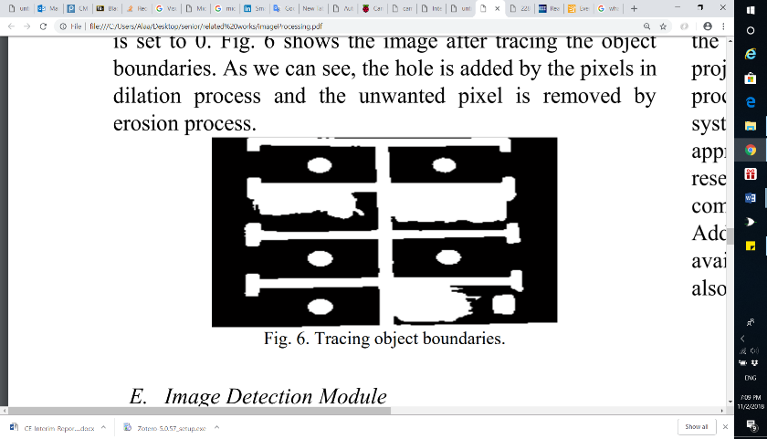4- Image Enhancement:

In this part the morphology functions such as dilation, erosion, opening and closing will be used to remove noise from the binary image. Also, these functions are used to trace the exterior boundaries of the object.

Figure ‎2‑5: Image after Tracing object boundaries

5- Image Detection Module:

In the last step the system will detect if the parking lot is empty or not by identify the rounded brown image at every spot.

Figure ‎2‑6: Detected parking spot

This approach may not function well in extreme weather conditions as the camera might be damaged. Also, camera must be placed in a suitable location where all parking areas are seen clearly and there are no objects that might obstructed the vision.

**Monitoring Parking Space Availability via Zigbee Technology**

In [14], the system’s main functionality is to allow its users to view the available parking spots through a screen at the gates of a parking area using Zigbee wireless technology for communication and digital infrared sensors for vehicle detection.

The system consists of two main modules:

Parking Lot Vacancy Monitoring Module

The module consists of digital infrared sensor, Zigbee module, PIC microcontroller 18F4550, and an LCD. This module is used to detect the available parking spots. To explain further, a digital infrared sensor is implemented on the top of each parking spot to detect the existence of a vehicle such that each sensor is used to monitor one parking spot. Infrared sensors work with reflected light wave and consist of an IR transmitter and an IR receiver. The IR transmitter emits infrared light, which gets reflected in case it met a reflecting surface (e.g. white color). The IR receiver then detects the reflected light and calculates the distance between the sensor and the object. The infrared sensor is interfaced with a PIC microcontroller, which is also interfaced with a Zigbee module for wireless transmission. When the sensor senses a vehicle in the parking spot, it informs the microcontroller, then the microcontroller informs the master module through the Zigbee module.

Master Module

The master module consists of GUI display shown through a PC or a laptop, and a Zigbee module. The GUI display, shown in Figure 2-7, allows the user to see exactly which parking spot is available. Whenever the Zigbee module receives data about a particular parking spot from the Parking Lot Vacancy Monitoring module, it informs the PC/laptop that it is interfaced with to update the status of a parking spot.

Furthermore, their system has several disadvantages. The infrared sensor is hugely dependent on light; as brighter surfaces are easier to detect than darker surfaces which the sensor does not detect. Hence, changing light conditions could give wrong outputs. Also, the system does not have a mobile for a remote user interface and is only restricted to a GUI interface at the gates of the parking lot.

The hardware architecture of the system is shown in Figure 2-8

Figure ‎2‑7: GUI Display on PC or laptop



Figure ‎2‑8: Hardware architecture of the system

**Smart Parking System (SPS) Architecture Using Ultrasonic Detector**

[15] is a smart parking system for multilevel parking lots which uses ultrasonic sensors to detect the occupancy of a car and shows it to the user at the parking area using display boards. The display boards display the number of available parking spots, and they are implemented indoors -at each entrance to each level and at the end of each aisle of the parking lot- and outdoors -at the entrance and exit of the parking lot-. Furthermore, an ultrasonic sensor is applied on the ceiling of a parking spot and is used to detect cars on that spot only. LEDs with different colors accompany each ultrasonic sensor to inform the user of the parking spot status (reserved, occupied, vacant or handicapped). The system includes a monitoring software and line detection system to detect improper parking. The line detection system is done by adding two additional ultrasonic sensors horizontally on the right and left of each parking spot such that they face the parking spot lines. Whenever a car goes through the detection line, an alarm will go off until the car is moved out of the line.



Figure ‎2‑9: Hardware architecture of the system

Figure 2-9 shows the overall hardware architecture of the system. The system consists of ultrasonic sensors, LED indicators, indoor display boards, outdoor display board(s), zone control unit (ZCU), central control unit (CCU), network switch, telephone cable and management software. When the ultrasonic sensor detects a change in the status of a parking area, it transmits the status to the zone control unit (ZCU) through a telephone cable. The ZCU then forwards the information to the central control unit (CCU) with Cat5 cables and sends commands to the indoor display boards and the LEDs on the parking sports to change status accordingly. Both the indoor display boards and the LEDs are connected to the ZCU through RS-485 ports. The ZCU is connected to the central control unit (CCU) through network switch and LAN connections. The CCU, upon receiving new information from any of the ZCUs, processes the data with the whole parking lot data, then transmits commands to the outdoor display boards to update the parking area information.

The system manages the multilevel parking area nicely. However, the system is wired with a lot of hardware components which has a huge number of cables. Any extension to the system would require more cables, and more complications on the system.

**Intelligent Parking System**

In [16], the system is based on image processing techniques which capture, and processes circles or rounded images drawn at parking lot and shown in an android application. This rounded image indicates the empty parking spaces to the users.

A camera is used with a sensor to take photos to show the occupancy of car parks. The information about whether a parking space is available or not is displayed on the application. If the space is available, a green circle is displayed to the user. As the camera detect the vacant space of parking and shown on the screen with green circles are placed on the vacant car parks. Green circle helps users so that users can easily differentiate whether a car is parked in a spot or not. So, if there is a car in a spot, no green circle will be shown at that spot.

The system contains three modules: Monitoring module, Control module and a displaying unit

The monitoring module has ultrasonic sensors which identifies the free parking spaces and transmits the Information to control unit which process/send information to the administrative system. Besides that, there’s a centralized system for supervisory receives information of parking space from the controller. It then sends the information to the user’s phone.

Below (Figure 2-10) illustrate the working process of the system



Figure ‎2‑10: Working process of the system

Related work comparison

Table ‎2‑1: Related work comparison

|  |  |  |  |  |  |  |  |  |
| --- | --- | --- | --- | --- | --- | --- | --- | --- |
| **Paper** | **Hardware Used** | | | **Service** | | | **User Interface Through** | **Connection** |
| **Microcontroller** | **Sensors** | **Others** | **Reservation** | **Availability checking** | **Payment** |
| **[11]** | Pic Microcontroller |  | LCD,  Motor driver |  |  |  | Visual Basic Application | GSM |
| **[13]** |  |  | Camera |  |  |  |  |  |
| **[14]** | Pic Microcontroller | Infrared Sensor | Zigbee- module  LCD |  |  |  | GUI displayed on PC or laptop | Wireless |
| **[15]** |  | Ultrasonic Sensor | Display  Boards,  LEDs,  Network Switch |  |  |  |  | Telephone cables, LAN connection |
| **[16]** |  | Ultrasonic sensors | Camera |  |  |  | Android Mobile Application |  |
| **Our Method** | Arduino Uno | Ultrasonic  RFID | Servo  motor,  LEDs |  |  |  | Mobile- Application  Website | Wireless |

Having compared the existing solutions to ours in Table XX, the following remarks come to mind. All the related works implement one of the following services (Checking Availability, Reservations, Payment) except [16]. [16] provides all the above services as we aim to do in our system. However, [16] only provides an Android application while we will provide in addition to that a website. Furthermore, the above approaches use ultrasonic, infrared and camera for car detection only. Our approach uses ultrasonic sensor for car detection and RFID (Radio Frequency Identification) for car identification and detection.

# Requirements analysis

In this section, the software development process used in this project is defined. The functional and nonfunctional requirements of the system are addressed.

## Software development process

The software development process in our project is Scrum. Scrum is an iterative and incremental agile software development process that focuses on adapting to rapid changes. Scrum was chosen for our project because it does not require us to know exactly how and what to do from the beginning of the development process. The Scrum process is responsive to changes and improvements with repeated reviews and work inspection [17]. Figure 3-1 shows the Scrum process overview



Figure ‎3‑1: Scrum process overview

The main part of the Scrum cycle is the Sprint. Each Sprint is time restricted to one week and has 4 steps as shown in Figure 3-2.



Figure ‎3‑2: Scrum cycle

**1. Sprint Planning**

At the beginning of the project, we collected the requirements into a Product Backlog from the users by researching the parking problem in Qatar University and the users’ needs. Before starting a Sprint, we hold up a meeting to decide on the top priority requirements from the Product Backlog and create a Sprint Backlog. The Sprint Backlog contains tasks that we think will be done during the Sprint which is in our case one week.

**2. Sprint**

In this stage, we start working on the tasks as specified in the Sprint Backlog. In addition, a Daily Scrum Meeting is held to discuss the tasks that was done by each member so far, and what will be done before the next meeting. Also, if any member has faced any difficulties during the task, we try to find a solution for it.

**3. Sprint Review**

At the end of a Sprint, a meeting is held with the ScrumMaster (supervisor) to demonstrate what was done. The ScrumMaster suggest solutions to the issues we faced during the Sprint.

**4. Sprint Retrospective**

After the Sprint Review, we refine our tasks to meet the comments and suggestions given by the ScrumMaster and decide on the improvements to be done to make the next Sprint smoother.

## Functional requirements

* An RFID reader should be installed and kept operational at the gate of the parking facility.
* VIP users must have an RFID tag in their possession before entering the parking facility.
* Sensors should be hardwired to Arduino.
* Arduino must be connected to a power source.
* Arduino must be connected to a Wi-Fi module.
* Firebase must have a connection with the Arduinos, the mobile application and the website via Wi-Fi.
* The mobile must have internet connection.
* The user should be a university member or visitor.

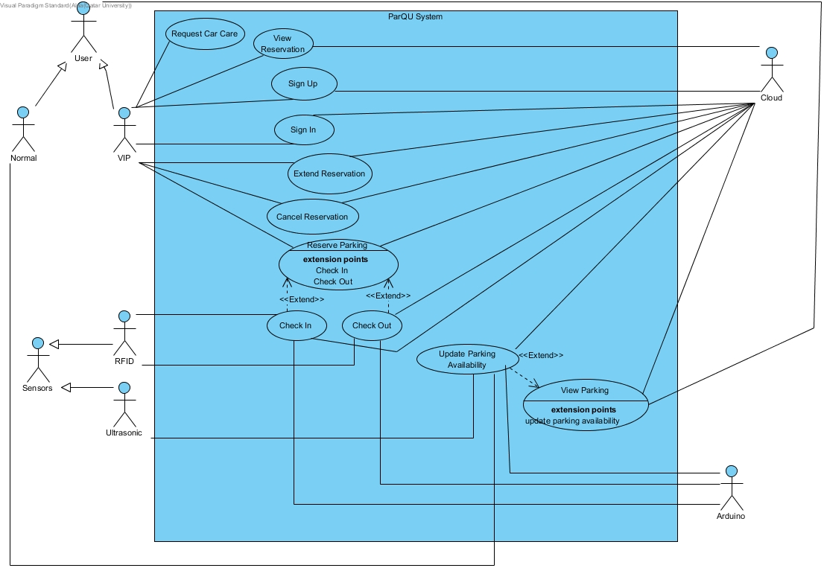

Figure ‎3‑3: Use case diagram

Table ‎3‑1: Actor type and descriptions

|  |  |
| --- | --- |
| Actor types | Description |
| VIP User | Anyone who subscribed to the VIP services such as reservation service and request car care service. |
| Normal User | Anyone who is not subscribed to the VIP services. |

Table ‎3‑2: Use cases and descriptions

|  |  |
| --- | --- |
| Use case | Brief description |
| Sign Up | VIP user registers in the system. |
| Sign In | VIP user logs into the system. |
| Reserve Parking | VIP user reserves a parking spot for several hours. |
| View Reservation | VIP user views reservation details. |
| Extend Reservation | The VIP user extends a reservation. |
| Cancel Reservation | The VIP user cancels a reservation. |
| Check In | The system reads the RFID tag on the car, checks its validity, then allows reserved VIP users only to enter the parking lot. |
| Check Out | The system reads the RFID tag on the car, checks its validity, then update available parking spots. |
| View Parking | The user views a map with the current status of parking spots. |
| Update Parking Availability | The system receives updated data from sensors through the Arduino board. |
| Request Car Care | The VIP user request car care service which will display contact numbers of car care company. |

## Non-functional requirements

**Design constraints**

Table ‎3‑3: Technical design constraints

|  |  |
| --- | --- |
| Name | Description |
| Reliability | Data is saved at all times on the Firebase database, so no data will be lost. |
| Scalability | The system can support the addition of sensors and components as well as having more users and the cloud can be upgraded accordingly. |
| Connectivity | Firebase database needs to be connected to the internet to collect updated data from the sensors through the Arduino board. Also, the mobile application needs to be connected to the internet to get the data |
| Availability | The system should be always available. During using the application, if any data changed in firebase database, the application should automatically display the updates without needing to refresh the page. |
| Mobility | The system can be accessed from two different platforms: an Android application and a website |
| Power | Power source needed for:  Motor: 3-7V  Sensor: 5V  Arduino: 7-12V |

Table ‎3‑4: Practical design constraints

|  |  |  |
| --- | --- | --- |
| Type | Name | Description |
| Economics | Cost | The prototype for availability module which consists of 4 parking spots should cost on average 270 QR.  The prototype for reservation module should cost on average 260 QR. |
| Social | Usability | A normal user with minimal software knowledge should be able to use the mobile application and the website with ease |
| Sustainability | Maintenance | The system’s component should be easy to replace, remove and implement. |
| Quality | Performance | The system should provide efficient information and accurate readings from the parking area. |

**Design standards**

Table ‎3‑5: Standard types and descriptions

|  |  |
| --- | --- |
| Standard Types | Description |
| Networking Standard | HTTP (Hypertext transfer protocol) |
| Security Standard | OpenID Connect (used for delegated authentication) |
| Wireless Standard | IEEE 802.11 (Wi-Fi) |
| Serial Communication Standards | SPI (Serial Peripheral Interface) |

## Assumptions

Below are some assumptions that are out of the scope of the work done in this project but necessary for the project to work properly:

* Arduino is always connected to the sensors.
* A power source is connected to the Arduino.
* Arduino always has a Wi-Fi connection.
* Firebase can always store data without limits.
* Application and website are always available.
* Mobile and PC that access our application and website is always connected to the internet.
* VIP user always has an RFID tag.

## Ethics

Table ‎3‑6: IEEE and ACM code of ethics

|  |  |
| --- | --- |
| Code | Project Perspective |
| IEEE  To seek, accept, and offer honest criticism of technical work, to acknowledge and correct errors, and to credit properly the contributions of others.  ACM  - Honor property rights including copyrights and patent.  - Give proper credit for intellectual property. | Any project or work used is referenced in this paper. Feedback will be accepted by the supervisor and the examiners. |
| IEEE  To treat fairly all persons and to engage in acts of discrimination based on race, religion, gender, disability, age, national origin, sexual orientation, gender identify, or gender expression.  ACM  - Be fair and take action not to discriminate. | Project members have all worked together to produce this work which can be used by all types of people. |
| IEEE  To assist colleagues and co-workers in their professional development and to support them in following this code of ethics. | The project is collaborative; every team member will work on it and ensure the code of ethics is strictly followed. |
| ACM  - Contribute to society and human well-being.  - Manage personnel and resources to design and build information systems that enhance the quality of working life. | The design aims to achieve better standards and benefits. |

# Proposed solution

The possible solutions for our system are listed with their properties. Then our solution is presented with the justification.

## Possible solutions and tradeoffs

The system has a software and hardware part. Each of these parts has its own possible solutions.

**Hardware possible solutions**

* Comparison between different sensors

There are many different sensors that can be used for detecting the presence of vehicles which are suitable for our smart parking system. One of them is the RFID (Radio Frequency Identification) method/technique/approach which comes with a reader and a tag. The idea is to use radio frequencies for detection and identification of each vehicle by installing an RFID tag on it. Another approach is to use an Infrared sensor which can detect a vehicle. This is done by detecting the reflected infrared light waves that the sensor emits. A third method is to use an Optical sensor that uses light rays that are converted into electrical signals for detection. Additionally, an Ultrasonic sensor can be used which emits and detects any reflected sound waves. Finally, a camera with the implementation of image processing can be used for detecting vehicles.

In [18], a study was conducted which compared the different types of sensors used in existing approaches. A short version of their table is provided in Table 4-1 below.

Table ‎4‑1: Comparison between different sensors

|  |  |  |  |  |  |
| --- | --- | --- | --- | --- | --- |
|  | Flexible | Small Size | Installation | Accuracy | Cost |
| Infrared |  |  | * | ** | * |
| Ultrasonic |  |  | * | *** | * |
| Camera |  |  | * | ** | *** |
| Optical |  |  | * | ** | * |
| RFID |  |  | ** | *** | ** |

* Comparison between different development boards

Arduino and Raspberry Pi development boards can both be used as part of our solution. In [19], a comparative table was made between the two. A short version of their table is provided in Table 4.2 below.

|  |  |  |
| --- | --- | --- |
| SL | Raspberry Pi | Arduino |
| 1 | It is a mini computer with Raspbian OS. It can run multiple programs at a time. | Arduino is a microcontroller, which is a part of the computer. It runs only one program again and again. |
| 2 | It is difficult to power using a battery pack. | Arduino can be powered using a battery pack. |
| 3 | It requires complex tasks like installing libraries and software for interfacing sensors and other components. | It is very simple to interface sensors and other electronic components to Arduino. |
| 4 | It is expensive. | It is available at a low cost. |
| 5 | The processor used is from ARM family. | Processor used in Arduino is from AVR family Atmega328P. |

Table ‎4‑2: Comparison between Raspberry Pi and Arduino

**Software possible solutions**

* Comparison between services

Availability and Reservations are the two main services that can be provided to the user. Availability is mainly about showing the user a map that shows the status of each parking spots being available or not. Reservation allows the user to reserve a parking spot before coming to the parking area.

The main 2 criteria that we are going to compare between them are flexibility, and guarantee of available parking spot.

Regarding the flexibility criteria, the availability service is more flexible than the reservation because whenever the user parks, he can stay in the parking for as long as he wants. However, in the case of reservation the user should leave whenever his reserved time is over. Users of the Reservation service guarantee the availability of parking spots once they successfully place a reservation. However, in the Availability service, users may not find the parking spot available if someone parks in the available spots at the time of arrival.

|  |  |  |
| --- | --- | --- |
| Services | Flexibility | Guarantee of available parking spot |
| Availability |  | X |
| Reservation | X |  |

Table ‎4‑3: Comparison between services

Regarding the reservation period/duration, there are several options that can be taken into consideration, but they vary in realism and defects. As mentioned in Table 4-4, it is possible to extend with hour-based reservation whilst it is not with day-based reservation. Using the day-based reservation approach, the parking spots will not be utilized to the maximum, as opposed to the hour-based reservation. For instance, if a user wanted to reserve a parking spot for one hour in a day-based reservation system, he will have to reserve the whole day which will waste a parking spot resource for a day. This also means the system cannot serve maximum number of users it is capable of.

Table ‎4‑4: Comparison between reservation duration options

|  |  |  |  |
| --- | --- | --- | --- |
| Reservation Duration | Extension possibility | Serve maximum number of users | Resources  utilization |
| Per hour | Possible |  |  |
| Per day | Not Possible | X | X |

## Proposed solution overview

After surveying the above options regarding the sensors, microcontrollers and services, we combined several components to give the best solution we think will satisfy the goals of the project. The proposed solution is a hybrid solution consisting of two main modules: A Reserved Parking module and a Reservation Free Parking module. The reasoning behind our design decisions will be provided throughout this section.

The modules will provide the user with the two main services discussed above; reservation and availability. However, each of these services along with some additional services will be given according to the type of user using our system. The system acknowledges two types of users: VIP users and Normal users. On the one hand, Normal users do not require registration nor any type of information from the user. On the other hand, VIP users require subscription registration and installation of an ID tag to be able to enter the parking area. Normal users will be given the availability service, VIP users will be given the availability, reservation and request car care services. The reservation includes additional services such as extension and cancellation. The Availability service gives Normal and VIP users the ability to view the current parking area status by displaying the parking area map with a status shown for each parking spot. The Reservation service allows a VIP user to reserve a parking spot.

To help us make some design decisions, we collected information about the user needs in our system by conducting a survey for QU students. To establish a suitable number of hours to reserve per day, we found from the survey, as shown in Figure 4-1, that on average the most appropriate number of hours to reserve per day is 6 hours. To account for exceptions, our system also provides reservation extension service in case there is a vacant parking spot at the time of the extension. Adding to the flexibility of our system, a VIP user is also allowed to cancel a reservation as late as one hour before the start of the reservation time. Although the hardware solution will be different for each of the modules, the software solution however will be somewhat similar.



Figure ‎4‑1: Statistics from Survey

**Software solution**

The software solution will be consisting of a mobile application, website and cloud service. Android studio is the software that is going to be used to build the mobile application. For the cloud service we select Firebase as it has many important features such as having a real time database. Moreover, Firebase provides APIs that supports Android and web development and that makes it easier to integrate on them. In addition to that, the FirebaseArduino library is a library that allows the Arduino to communicate with the Firebase database directly without the need to have a server in between. For front-end web development, Vue.js, HTML, CSS and JavaScript will be used and for the back-end development a Firebase real time database will be used.

Regarding to the database design, the system will need to store information about 5 main components which are VIP Users, Cars, Reservations, Parking area (Zone) and Spots. The following figure illustrates the overall schema for the system:

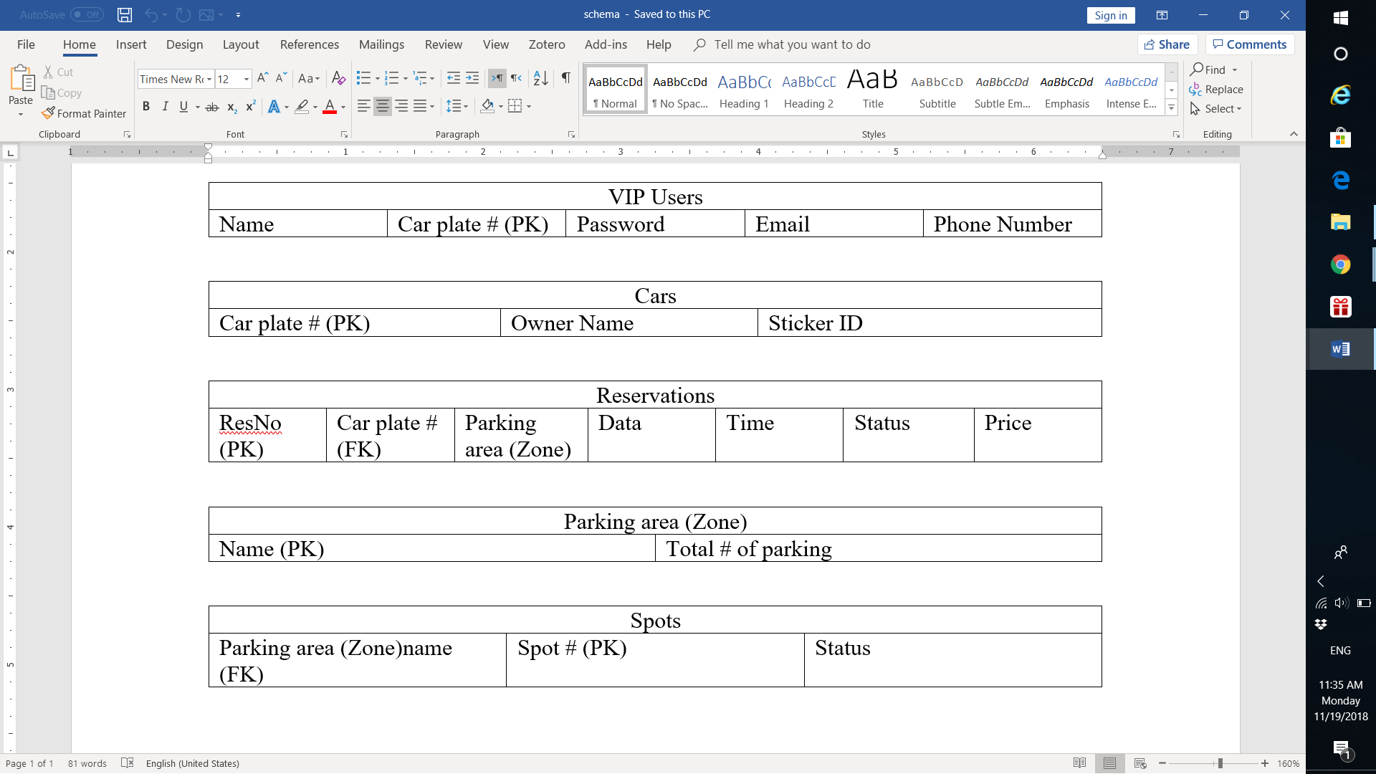

Figure ‎4‑2: Database schema

**Hardware solution**

The proposed hardware solution will be divided according to the module. The Reservation Free Parking module’s hardware solution will consist of an Ultrasonic sensor to detect if there is a car, Arduino board to collect information from the sensors and NodeMCU to allow the Arduino to send and receive data to the Firebase. The Reservation Free Parking module needs a sensor implemented on each parking spot and so in total a huge number of sensors will be needed depending on the number of parking spots. The Ultrasonic sensor has a high accuracy and a low cost. Hence, it was chosen among the other sensors in Table 4-2. Also, the Arduino was chosen over the Raspberry Pi because it is suitable for interfacing sensors with it and has a low cost which makes it more scalable.

In addition, the hardware solution for the Reserved Parking module will consist of an RFID reader to read the RFID tag on the car, Arduino board to collect information from the RFID reader, Servo motor to be the gates of the parking area and NodeMCU to allow the Arduino to send and receive data to the Firebase. The RFID was chosen because it provides an important functionality over the other sensors in Table 4-2. Unlike the other methods, RFID is able to identify exactly the users entering and leaving the parking area. Hence, the RFID sensor can be implemented at the gates of the parking area and the system only allows those who have registered and reserved a parking spot to enter. The Arduino was also chosen in this module because it is more suitable for the RFID and the Servo motor to be interfaced with. To power the system in our testing prototype, a 9V to barrel jack adapter will be used. However, a power grid should be used in real life implementation

## 

**High level architecture**

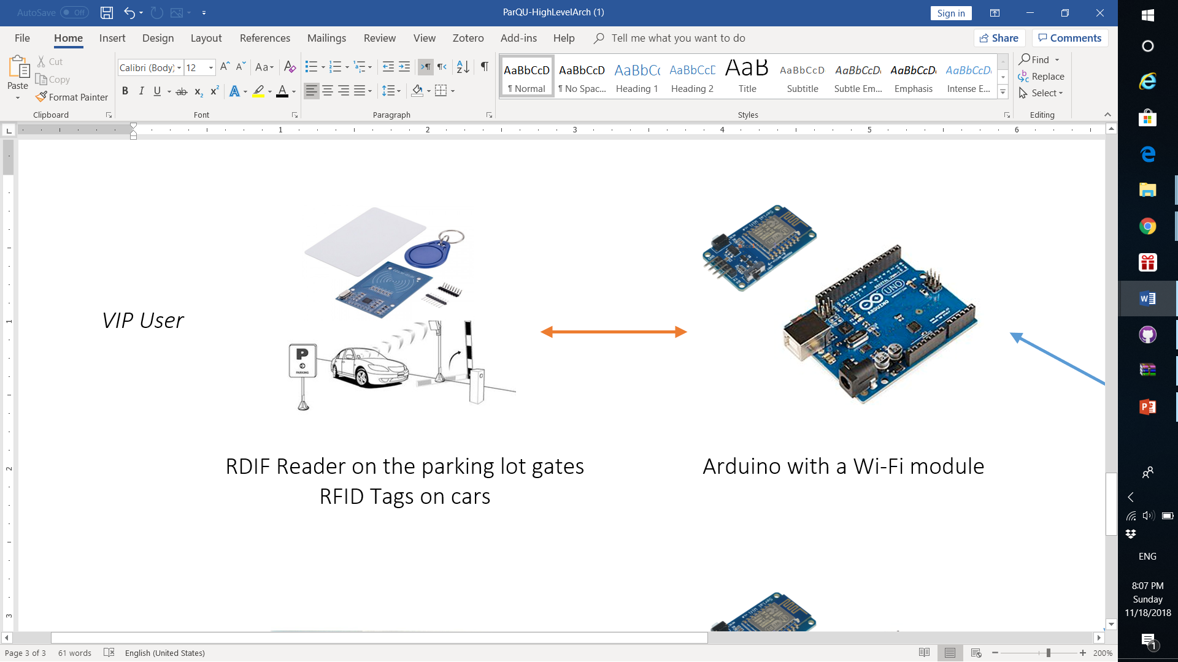

Reserved Parking Module

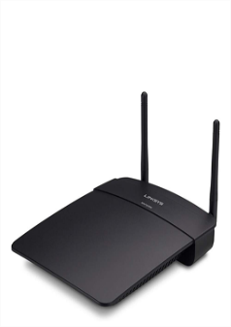



Reservation Free Parking Module

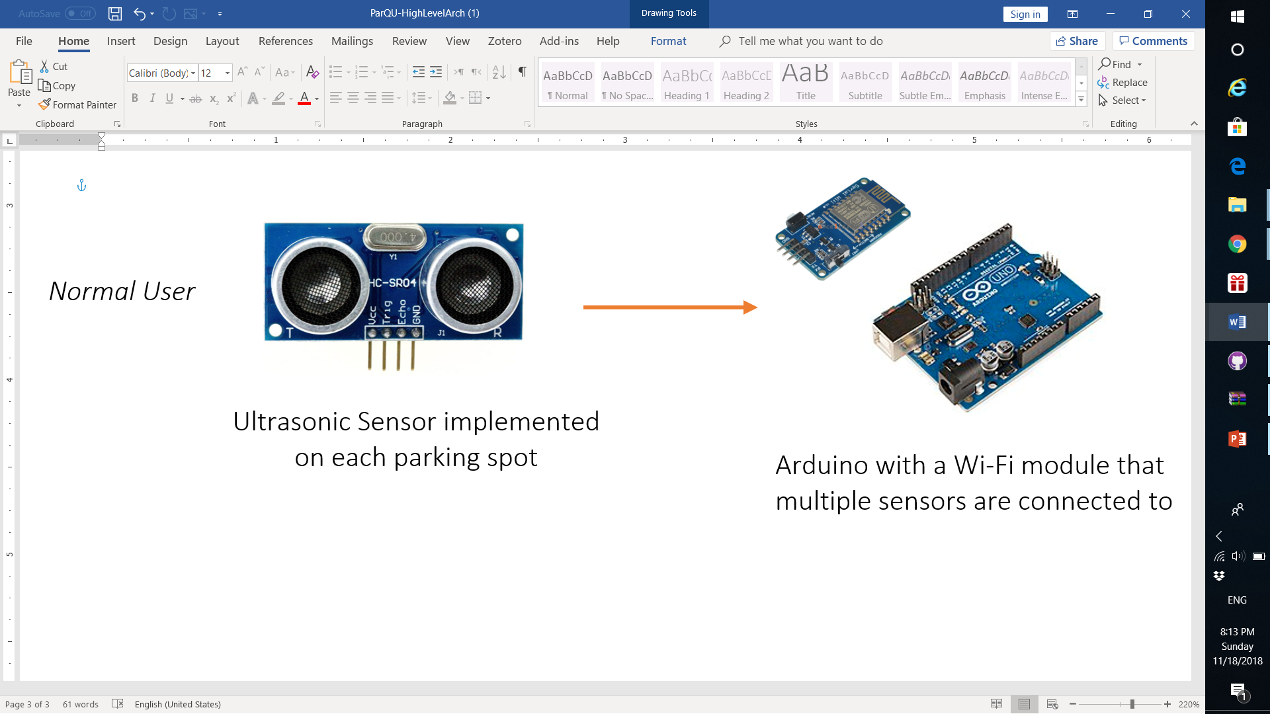

Internet

Wi-Fi

Serial Communication

* Reserved Parking Module

In this module the user is required to reserve through mobile application or website. Whenever the user arrives at the gate of the parking area, the RFID reader will read the RFID tag and send the information to Arduino. The Arduino will send the acquired data via Wi-Fi to the (Firebase) cloud database service. The application running on the Arduino module will check the response received from Firebase if there is a reservation associated with this tag at this date and time. If the response is verified, then the Arduino will order the Servo motor to open or close accordingly. The connection between RFID sensor and Arduino is serial.

* Reservation Free Parking Module

The main purpose of this module is to let the users know if there are available parking spots in a certain zone through a mobile application or website. The application will display the current parking area status in a real time manner by showing a map. Whenever a car is parked in an available space, the Ultrasonic sensor will detect it and inform the Arduino which will then update the Firebase. The connection between Ultrasonic sensor and Arduino is serial.

Both modules have a Wi-Fi connection with Firebase whilst the application or website is connected to the Firebase through the internet.

## Hardware/software to be used

**Hardware components**

Table ‎4‑5: Hardware components with descriptions

|  |  |  |  |
| --- | --- | --- | --- |
| Component Name | Description | Price | Image |
| NodeMCU V2 Model ESP8266 | NodeMCU V2 is an open source IoT platform.  It includes firmware which runs on the ESP8266 Wi-Fi SoC. This chip is going to establish the connection between Arduino and the Firebase database. | 44 QR | https://res.cloudinary.com/www-arduiely-com/image/upload/v1477989507/ejc2rdha8cphsxxyrulr.jpg  Figure ‎4‑3: NodeMCU model ESP8266 |
| Ultrasonic Sensor - HC-SR04 | Ultrasonic sensor to detect whether a car is parked or not | 17 QR | https://res.cloudinary.com/www-arduiely-com/image/upload/v1477387012/hbo10xrcxwqwcqwgfl6e.jpg  Figure ‎4‑4: Ultrasonic sensor - HC-SR04 |
| Mini Servo - Positional Rotation | The servo-positional motor will be used to open/close the gate of the parking lot by turning 90 degrees. | 20 QR | https://res.cloudinary.com/www-arduiely-com/image/upload/v1477385541/ankjsct9xu0guy3ceby6.jpg  Figure ‎4‑5: Mini Servo - positional rotation |
| RFID Kit | RFID Kit that includes an RFID Reader module, round tag, and RFID card. The RFID tags are put on the cars as an identification, then the RFID reader is used to read the tags and identify cars at the gates of the parking lot. | 35 QR | FID kit  Figure ‎4‑6: RFID kit |
| 9V to Barrel Jack Adapter | This cable is used to battery-power the Arduino that needs 9V and has an on-board barrel jack | 4 QR | V to Barrel Jack Adapter  Figure ‎4‑7: 9V to barrel jack adapter |
| Full-Size Breadboard and Jumper Wires | For the connections between the different parts and Arduino we will be using full-size breadboard  and jumper wires. | 20+20 QR | https://res.cloudinary.com/www-arduiely-com/image/upload/v1477354013/zpip78vzw7yclkwfzbwq.jpg  Figure ‎4‑8: Full-size breadboard and jumper wires |
| Arduino Uno | Arduino Uno used to process the information given from the sensors and RFID reader | 115 QR | rduino Uno Rev3  Figure ‎4‑9: Arduino Uno |

**Software components**

Table ‎4‑6: Software components and descriptions

|  |  |  |
| --- | --- | --- |
| Software | Image | Description |
| Firebase | C:\Users\Alaa\AppData\Local\Microsoft\Windows\INetCache\Content.MSO\CEBC0621.tmp  Figure ‎4‑10: Firebase | Firebase is a complete backend solution that can manage authentication, real time database and hosting as well. It can be used in iOS apps, android apps and even in web apps. |
| Android Studio v.3 | https://lh6.googleusercontent.com/jTvi6UxK1jbVlVwhfCD0vq2tQoF305WO86a6fDMDvc9Q-t-6C9acI10janx4Sq3pdawF8nmT8UIf3lYLRIhe-387lXfUGVKqZpkfU4Oln3CtelwOJ8_t5qEk1LPIhE5H0cO3gXDh  Figure ‎4‑11: Android Studio | Android Studio is the official IDE for Android development. It can be used to design user-friendly app as it has a variety of built-in functionality. |
| Arduino IDE | C:\Users\Alaa\AppData\Local\Microsoft\Windows\INetCache\Content.MSO\973B0CFD.tmp  Figure ‎4‑12: Arduino IDE | Arduino software supports C/C++ based programming language. Used to write program to control the Arduino microprocessor to generate feedback. |
| WebStorm | C:\Users\Alaa\AppData\Local\Microsoft\Windows\INetCache\Content.MSO\2BF120DE.tmp  Figure ‎4‑13: WebStorm | WebStorm is JavaScript IDE that is used to build website applications. |

# Project plan

The implementation of the project is divided into phases which explain the tasks done by each member.

## Project milestones

**Phase-1**

Table ‎5‑1: Milestone Fall 2018

|  |  |
| --- | --- |
| Milestone | Tasks |
| Milestones -1 Information gathering | * Research about the project problem to prove the necessity of a solution. * Agree on a problem statement * Write a brief overview abstract |
| Milestones -2 Introduction and motivation | * Determine the technical and non-technical challenges and finalize the problem statement * Perform a survey to study the possible parking problems in Qatar University * Determine the significance of the project and how the outcomes of the project will benefit the users * Identify the aim and objective of the project |
| Milestones -3  Hardware and software to be used | * Search about all possible hardware components that might be used to solve the problem. * Prepare an excel sheet that has the decided-on hardware with its price * Search about Firebase and how it can be connected to the mobile application and Arduino |
| Milestones -4  Related work | * Read multiple papers with similar approaches to our problem in addition to the survey papers about same topic * Analyze the method used in on each selected paper * Deliver a table that lists all the similarities and differences between our approach and the other approaches. |
| Milestone-5 Requirement analysis | * Determine functional requirements * Design a use case diagram * Write use case specifications * Determine the technical and practical design constrains * List the design standards * List code of ethics |
| Milestone-6  Proposed solution | * List all the possible solutions for hardware and software parts and analyze their tradeoffs * Selected solution overview * Design high level architecture for the selected solution |
| Milestone-7  Complete interim report | * Gather all the work done in the interim report * Revise all parts of the report with the supervisor and get feedback * Complete and submit the report |
| Milestone-8 Presentation | * Prepare the presentation * Demonstrate the project to the examiners |

**Phase-2**

Table ‎5‑2: Milestone Spring 2019

|  |  |
| --- | --- |
| Milestone | Tasks |
| Milestones -1  Finalize Design | * Finalize use cases * Design a rough diagram of the circuit and how all the hardware components will be connected to each other |
| Milestones -2  Implementation | * Connect sensors to the Arduino * Connect Arduino to the Firebase database * Build hardware prototype * Implement mobile application * Implement website |
| Milestones -3  Testing | * Testing and verification of the system |
| Milestones -4  Documentation | * Gather all the work done in the report * Complete and submit the report |
| Milestones -5  Presentation + Poster | * Prepare the presentation * Prepare the Poster * Demonstrate the project to the examiners |

## Project timeline

Table ‎5‑3: Timeline Fall 2018

|  |  |  |  |  |  |  |  |  |  |  |  |  |  |  |  |  |  |  |  |  |  |  |  |  |  |  |  |  |  |  |  |  |  |  |  |  |  |  |  |  |  |  |  |  |  |  |  |  |  |  |  |  |  |  |  |  |  |  |  |  |  |  |  |  |  |  |  |  |  |  |  |  |  |  |  |  |  |  |  |  |  |  |  |  |  |  |  |  |  |  |  |  |  |  |  |  |  |  |  |  |  |  |  |  |  |  |  |  |  |  |  |  |  |  |  |  |  |  |  |  |  |  |  |  |  |  |  |  |  |  |  |  |  |  |  |  |  |  |  |  |  |  |  |  |  |  |  |  |  |  |  |  |  |  |  |  |  |  |  |  |  |  |  |  |  |  |  |  |  |  |  |  |  |  |  |  |  |  |  |  |  |  |  |  |  |  |  |  |  |  |  |  |  |  |  |  |  |  |  |  |  |  |  |  |  |  |  |  |  |  |  |  |  |  |  |  |  |  |  |  |  |  |  |  |  |  |  |  |  |  |  |  |  |  |  |  |  |  |  |  |  |  |  |  |  |  |  |  |  |  |  |  |  |  |  |  |  |  |  |  |  |  |  |  |  |  |  |  |  |  |  |  |  |  |  |  |  |  |  |  |  |  |  |  |  |  |  |  |  |  |  |  |  |  |  |  |  |  |  |  |  |  |  |  |  |  |  |  |  |  |  |  |  |  |  |  |  |  |  |  |  |  |  |  |  |  |  |  |  |  |  |  |  |  |  |  |  |  |  |  |  |  |  |  |  |  |  |  |  |  |  |  |  |  |  |  |  |  |  |  |  |  |  |  |  |  |  |  |  |  |  |  |  |  |  |  |  |  |  |  |  |  |  |  |  |  |  |  |  |  |  |  |  |  |  |  |  |  |  |  |  |  |  |  |  |  |  |  |  |  |  |  |  |  |  |  |  |  |  |  |  |  |  |  |  |  |  |  |  |  |  |  |  |  |  |  |  |  |  |  |  |  |  |  |  |  |  |  |  |  |  |  |  |  |  |  |  |  |  |  |  |  |  |  |  |  |  |  |  |  |  |  |  |  |  |  |  |  |  |  |  |  |  |  |  |  |  |  |  |  |  |  |  |  |  |  |  |  |  |  |  |  |  |  |  |  |  |  |  |  |  |  |  |  |  |  |  |  |  |  |  |  |  |  |  |  |  |  |  |  |  |  |  |  |  |  |  |  |  |  |  |  |  |  |  |  |  |  |  |  |  |  |  |  |  |  |  |  |  |  |  |  |  |  |  |  |  |  |  |  |  |  |  |  |  |  |
| --- | --- | --- | --- | --- | --- | --- | --- | --- | --- | --- | --- | --- | --- | --- | --- | --- | --- | --- | --- | --- | --- | --- | --- | --- | --- | --- | --- | --- | --- | --- | --- | --- | --- | --- | --- | --- | --- | --- | --- | --- | --- | --- | --- | --- | --- | --- | --- | --- | --- | --- | --- | --- | --- | --- | --- | --- | --- | --- | --- | --- | --- | --- | --- | --- | --- | --- | --- | --- | --- | --- | --- | --- | --- | --- | --- | --- | --- | --- | --- | --- | --- | --- | --- | --- | --- | --- | --- | --- | --- | --- | --- | --- | --- | --- | --- | --- | --- | --- | --- | --- | --- | --- | --- | --- | --- | --- | --- | --- | --- | --- | --- | --- | --- | --- | --- | --- | --- | --- | --- | --- | --- | --- | --- | --- | --- | --- | --- | --- | --- | --- | --- | --- | --- | --- | --- | --- | --- | --- | --- | --- | --- | --- | --- | --- | --- | --- | --- | --- | --- | --- | --- | --- | --- | --- | --- | --- | --- | --- | --- | --- | --- | --- | --- | --- | --- | --- | --- | --- | --- | --- | --- | --- | --- | --- | --- | --- | --- | --- | --- | --- | --- | --- | --- | --- | --- | --- | --- | --- | --- | --- | --- | --- | --- | --- | --- | --- | --- | --- | --- | --- | --- | --- | --- | --- | --- | --- | --- | --- | --- | --- | --- | --- | --- | --- | --- | --- | --- | --- | --- | --- | --- | --- | --- | --- | --- | --- | --- | --- | --- | --- | --- | --- | --- | --- | --- | --- | --- | --- | --- | --- | --- | --- | --- | --- | --- | --- | --- | --- | --- | --- | --- | --- | --- | --- | --- | --- | --- | --- | --- | --- | --- | --- | --- | --- | --- | --- | --- | --- | --- | --- | --- | --- | --- | --- | --- | --- | --- | --- | --- | --- | --- | --- | --- | --- | --- | --- | --- | --- | --- | --- | --- | --- | --- | --- | --- | --- | --- | --- | --- | --- | --- | --- | --- | --- | --- | --- | --- | --- | --- | --- | --- | --- | --- | --- | --- | --- | --- | --- | --- | --- | --- | --- | --- | --- | --- | --- | --- | --- | --- | --- | --- | --- | --- | --- | --- | --- | --- | --- | --- | --- | --- | --- | --- | --- | --- | --- | --- | --- | --- | --- | --- | --- | --- | --- | --- | --- | --- | --- | --- | --- | --- | --- | --- | --- | --- | --- | --- | --- | --- | --- | --- | --- | --- | --- | --- | --- | --- | --- | --- | --- | --- | --- | --- | --- | --- | --- | --- | --- | --- | --- | --- | --- | --- | --- | --- | --- | --- | --- | --- | --- | --- | --- | --- | --- | --- | --- | --- | --- | --- | --- | --- | --- | --- | --- | --- | --- | --- | --- | --- | --- | --- | --- | --- | --- | --- | --- | --- | --- | --- | --- | --- | --- | --- | --- | --- | --- | --- | --- | --- | --- | --- | --- | --- | --- | --- | --- | --- | --- | --- | --- | --- | --- | --- | --- | --- | --- | --- | --- | --- | --- | --- | --- | --- | --- | --- | --- | --- | --- | --- | --- | --- | --- | --- | --- | --- | --- | --- | --- | --- | --- | --- | --- | --- | --- | --- | --- | --- | --- | --- | --- | --- | --- | --- | --- | --- | --- | --- | --- | --- | --- | --- | --- | --- | --- | --- | --- | --- | --- | --- | --- | --- | --- | --- | --- | --- | --- | --- | --- | --- | --- | --- | --- | --- | --- | --- | --- | --- | --- | --- | --- | --- | --- | --- | --- | --- | --- | --- | --- | --- | --- | --- | --- | --- | --- | --- | --- | --- | --- | --- | --- | --- | --- | --- | --- | --- | --- | --- | --- | --- | --- | --- | --- | --- | --- | --- | --- | --- | --- | --- | --- | --- | --- | --- | --- | --- | --- |
| |  |  |  |  |  |  |  |  |  |  |  |  |  |  |  |  | | --- | --- | --- | --- | --- | --- | --- | --- | --- | --- | --- | --- | --- | --- | --- | --- | | Tasks | Week 1 | Week 2 | Week 3 | Week 4 | Week 5 | Week 6 | Week 7 | Week 8 | Week 9 | Week  10 | Week 11 | Week 12 | Week 13 | Week 14 | Week 15 | | **Milestones -1 Information gathering** |  |  |  |  |  |  |  |  |  |  |  |  |  |  |  | | Research about the project problem to prove the necessity of a solution |  |  |  |  |  |  |  |  |  |  |  |  |  |  |  | | Agree on a problem statement |  |  |  |  |  |  |  |  |  |  |  |  |  |  |  | | Write a brief overview abstract |  |  |  |  |  |  |  |  |  |  |  |  |  |  |  | | **Milestones -2**  **Introduction and motivation** |  |  |  |  |  |  |  |  |  |  |  |  |  |  |  | | Determine the technical and non-technical challenges and finalize the problem statement |  |  |  |  |  |  |  |  |  |  |  |  |  |  |  | | Perform a survey to study the possible parking problems in Qatar University |  |  |  |  |  |  |  |  |  |  |  |  |  |  |  | | Determine the significance of the project and how the outcomes of the project will benefit the users |  |  |  |  |  |  |  |  |  |  |  |  |  |  |  | | Identify the aim and objective of the project |  |  |  |  |  |  |  |  |  |  |  |  |  |  |  | | **Milestones -3**  **Hardware and software to be used** |  |  |  |  |  |  |  |  |  |  |  |  |  |  |  | | Search about all possible hardware components that might be used to solve the problem |  |  |  |  |  |  |  |  |  |  |  |  |  |  |  | | Prepare an excel sheet that has the decided-on hardware with its price |  |  |  |  |  |  |  |  |  |  |  |  |  |  |  | | Search about Firebase and how it can be connected to the mobile application and Arduino |  |  |  |  |  |  |  |  |  |  |  |  |  |  |  | | **Milestones -4**  **Related work** |  |  |  |  |  |  |  |  |  |  |  |  |  |  |  | | Read multiple papers with similar approaches to our problem in addition to the survey papers about same topic |  |  |  |  |  |  |  |  |  |  |  |  |  |  |  | | Analyze the method used in on each selected paper |  |  |  |  |  |  |  |  |  |  |  |  |  |  |  | | Deliver a table that lists all the similarities and differences between our approach and the other approaches |  |  |  |  |  |  |  |  |  |  |  |  |  |  |  | | **Milestone-5 Requirement analysis** |  |  |  |  |  |  |  |  |  |  |  |  |  |  |  | | Determine functional requirements |  |  |  |  |  |  |  |  |  |  |  |  |  |  |  | | Design a use case diagram |  |  |  |  |  |  |  |  |  |  |  |  |  |  |  | | Write use case specifications |  |  |  |  |  |  |  |  |  |  |  |  |  |  |  | | Determine the technical and practical design constrains |  |  |  |  |  |  |  |  |  |  |  |  |  |  |  | | List the design standards |  |  |  |  |  |  |  |  |  |  |  |  |  |  |  | | List code of ethics |  |  |  |  |  |  |  |  |  |  |  |  |  |  |  | | **Milestone-6**  **Proposed solution** |  |  |  |  |  |  |  |  |  |  |  |  |  |  |  | | List all the alternative solutions for hardware and software parts and analyze their tradeoffs |  |  |  |  |  |  |  |  |  |  |  |  |  |  |  | | Selected solution overview |  |  |  |  |  |  |  |  |  |  |  |  |  |  |  | | Design high level architecture for the selected solution |  |  |  |  |  |  |  |  |  |  |  |  |  |  |  | | **Milestone-7**  **Complete interim report** |  |  |  |  |  |  |  |  |  |  |  |  |  |  |  | | Gather all the work done in the interim report |  |  |  |  |  |  |  |  |  |  |  |  |  |  |  | | Revise all parts of the report with the supervisor and get feedback |  |  |  |  |  |  |  |  |  |  |  |  |  |  |  | | Complete and submit the report |  |  |  |  |  |  |  |  |  |  |  |  |  |  |  | | **Milestone-8**  **Presentation** |  |  |  |  |  |  |  |  |  |  |  |  |  |  |  | | Prepare the presentation |  |  |  |  |  |  |  |  |  |  |  |  |  |  |  | | Demonstrate the project to the examiners |  |  |  |  |  |  |  |  |  |  |  |  |  |  |  | |

|  |  |  |  |  |  |  |  |  |  |  |  |  |  |  |  |  |  |  |  |  |  |  |  |  |  |  |  |  |  |  |  |  |  |  |  |  |  |  |  |  |  |  |  |  |  |  |  |  |  |  |  |  |  |  |  |  |  |  |  |  |  |  |  |  |  |  |  |  |  |  |  |  |  |  |  |  |  |  |  |  |  |  |  |  |  |  |  |  |  |  |  |  |  |  |  |  |  |  |  |  |  |  |  |  |  |  |  |  |  |  |  |  |  |  |  |  |  |  |  |  |  |  |  |  |  |  |  |  |  |  |  |  |  |  |  |  |  |  |  |  |  |  |  |  |  |  |  |  |  |  |  |  |  |  |  |  |  |  |  |  |  |  |  |  |  |  |  |  |  |  |  |  |  |  |  |  |  |  |  |  |  |  |  |  |  |  |  |  |  |  |  |  |  |  |  |  |  |  |  |  |  |  |  |  |  |  |  |  |  |  |  |  |  |  |  |  |  |  |  |  |  |  |  |  |  |  |  |  |  |  |  |  |  |  |  |  |  |  |  |  |  |  |  |  |  |  |  |  |  |  |  |  |  |  |  |  |  |  |  |  |  |  |  |  |  |  |  |  |  |  |  |  |  |  |  |  |  |  |  |  |  |  |  |  |  |  |  |  |  |  |  |  |  |  |  |  |  |  |  |  |  |  |  |  |
| --- | --- | --- | --- | --- | --- | --- | --- | --- | --- | --- | --- | --- | --- | --- | --- | --- | --- | --- | --- | --- | --- | --- | --- | --- | --- | --- | --- | --- | --- | --- | --- | --- | --- | --- | --- | --- | --- | --- | --- | --- | --- | --- | --- | --- | --- | --- | --- | --- | --- | --- | --- | --- | --- | --- | --- | --- | --- | --- | --- | --- | --- | --- | --- | --- | --- | --- | --- | --- | --- | --- | --- | --- | --- | --- | --- | --- | --- | --- | --- | --- | --- | --- | --- | --- | --- | --- | --- | --- | --- | --- | --- | --- | --- | --- | --- | --- | --- | --- | --- | --- | --- | --- | --- | --- | --- | --- | --- | --- | --- | --- | --- | --- | --- | --- | --- | --- | --- | --- | --- | --- | --- | --- | --- | --- | --- | --- | --- | --- | --- | --- | --- | --- | --- | --- | --- | --- | --- | --- | --- | --- | --- | --- | --- | --- | --- | --- | --- | --- | --- | --- | --- | --- | --- | --- | --- | --- | --- | --- | --- | --- | --- | --- | --- | --- | --- | --- | --- | --- | --- | --- | --- | --- | --- | --- | --- | --- | --- | --- | --- | --- | --- | --- | --- | --- | --- | --- | --- | --- | --- | --- | --- | --- | --- | --- | --- | --- | --- | --- | --- | --- | --- | --- | --- | --- | --- | --- | --- | --- | --- | --- | --- | --- | --- | --- | --- | --- | --- | --- | --- | --- | --- | --- | --- | --- | --- | --- | --- | --- | --- | --- | --- | --- | --- | --- | --- | --- | --- | --- | --- | --- | --- | --- | --- | --- | --- | --- | --- | --- | --- | --- | --- | --- | --- | --- | --- | --- | --- | --- | --- | --- | --- | --- | --- | --- | --- | --- | --- | --- | --- | --- | --- | --- | --- | --- | --- | --- | --- | --- | --- | --- | --- | --- | --- | --- | --- | --- | --- | --- | --- | --- | --- | --- | --- | --- | --- | --- | --- | --- | --- | --- | --- | --- | --- | --- |
| |  |  |  |  |  |  |  |  |  |  |  |  |  |  |  |  | | --- | --- | --- | --- | --- | --- | --- | --- | --- | --- | --- | --- | --- | --- | --- | --- | | Tasks | Week 1 | Week 2 | Week 3 | Week 4 | Week 5 | Week 6 | Week 7 | Week 8 | Week 9 | Week 10 | Week 11 | Week 12 | Week 13 | Week 14 | Week 15 | | **Milestones -1**  **Finalize Design** |  |  |  |  |  |  |  |  |  |  |  |  |  |  |  | | Finalize use cases |  |  |  |  |  |  |  |  |  |  |  |  |  |  |  | | Design a rough diagram of the circuit and how all the hardware components will be connected to each other |  |  |  |  |  |  |  |  |  |  |  |  |  |  |  | | **Milestones -2 Implementation** |  |  |  |  |  |  |  |  |  |  |  |  |  |  |  | | Connect sensors to the Arduino |  |  |  |  |  |  |  |  |  |  |  |  |  |  |  | | Connect Arduino to the Firebase database |  |  |  |  |  |  |  |  |  |  |  |  |  |  |  | | Build hardware prototype |  |  |  |  |  |  |  |  |  |  |  |  |  |  |  | | Implement website |  |  |  |  |  |  |  |  |  |  |  |  |  |  |  | | Implement mobile application |  |  |  |  |  |  |  |  |  |  |  |  |  |  |  | | **Milestones -3**  **Testing** |  |  |  |  |  |  |  |  |  |  |  |  |  |  |  | | Testing and verification of the system |  |  |  |  |  |  |  |  |  |  |  |  |  |  |  | | **Milestones -4 Documentation** |  |  |  |  |  |  |  |  |  |  |  |  |  |  |  | | Gather all the work done in the report |  |  |  |  |  |  |  |  |  |  |  |  |  |  |  | | Complete and submit the report |  |  |  |  |  |  |  |  |  |  |  |  |  |  |  | | **Milestones -5**  **Presentation + Poster** |  |  |  |  |  |  |  |  |  |  |  |  |  |  |  | | Prepare the presentation |  |  |  |  |  |  |  |  |  |  |  |  |  |  |  | | Prepare the Poster |  |  |  |  |  |  |  |  |  |  |  |  |  |  |  | | Demonstrate the project to the examiners |  |  |  |  |  |  |  |  |  |  |  |  |  |  |  | |

|  |  |
| --- | --- |
|  | Amal |
|  | Ghareisa |
|  | Alaa |
|  | All |
|  | Alaa & Ghareisa | |

## Anticipated risks

Table ‎5‑5: Risks and solutions

|  |  |
| --- | --- |
| Risks | Proposed solutions |
| Obtaining wrong results from the sensor | Search for high quality sensors that would give correct results |
| Data is not transmitted in real-time (there is a delay) | Try to identify the source of the delay, and search for methods to minimize the delay |
| Obtaining wrong results from the RFID sensor | Change the type of the RFID to one that suits the wanted distance |
| User does not leave the parking when his reservation time ends | Have several back up parking spots |
| The application and/or the website receive an unexpectedly huge number of users such that the database storage reaches its limit | Upgrade the Firebase to have more data storage |

## Conclusion

Qatar University suffers from a parking problem which motivated us to search for a solution. At the beginning, we gathered information from QU attendants about the parking issue. Then we researched about the possible existing solutions and came up with our own design of a parking system that is suitable for the environment of Qatar University. For our future work, we will implement a prototype that shows the functionalities of our solution along with an Android mobile application and a website. The prototype will be tested to verify that the system works according to our plan and helps in solving the parking issue in our university.

# References

[1] “Qatar-Education Statistics, 2013,” *Arab Development Portal*, 23-Aug-2017. [Online]. Available: http://arabdevelopmentportal.com/publication/qatar-education-statistics-2013. [Accessed: 02-Oct-2018].

[2] “About”, *Qatar University*. [Online]. Available: http://www.qu.edu.qa/about. [Accessed: 24-Nov-2018].

[3] Al-Arab, (2016). [online] Available at: http://www.alarab.qa/story/1010307. [Accessed 17 Sep. 2018

[4] Al-Watan, (2018). [online] Available at: http://www.al-watan.com/news-details/id/156085. [Accessed 12 Oct. 2018.

[5] Al-Watan (2018). [online] Available at: http://www.al-watan.com/news-details/id/129483. [Accessed 12 Oct. 2018].

[6] S. A. Shaheen and C. Kemmerer, “Smart Parking Linked to Transit,” *Transportation Research Record: Journal of the Transportation Research Board*, vol. 2063, no. 1, pp. 73–80, 2008. [online]. Available: https://journals.sagepub.com/toc/trra/2063/1

[7] J. Chinrungrueng, U. Sunantachaikul and S. Triamlumlerd, "Smart Parking: An Application of Optical Wireless Sensor Network," *2007 International Symposium on Applications and the Internet Workshops*, Hiroshima, 2007, pp. 66-66. doi: 10.1109/SAINT-W.2007.98. available: http://ieeexplore.ieee.org/stamp/stamp.jsp?tp=&arnumber=4090136&isnumber=4090057

[8] D. Pojani, I. Mateo-Babiano, J. Corcoran, and N. Sipe, “Should we get rid of parking spaces to free up land in our cities?” *ABC News*, 06-Nov-2017. [Online]. Available: https://www.abc.net.au/news/2017-10-30/should-we-get-rid-of-car-parks-to-free-up-land-in-our-cities/9099272. [Accessed: 26-Oct-2018].

[9] D. Pojani, I. Mateo-Babiano, J. Corcoran, and N. Sipe, “Freeing up the huge areas set aside for parking can transform our cities,” *The Conversation*, 09-Nov-2018. [Online]. Available: http://theconversation.com/freeing-up-the-huge-areas-set-aside-for-parking-can-transform-our-cities-85331. [Accessed: 12-Nov-2018].

[10] INRIX, “Searching for Parking Costs Americans $73 Billion a Year - INRIXINRIX,” *INRIX*. [Online]. Available: http://inrix.com/press-releases/parking-pain-us/. [Accessed: 19-Nov-2018].

[11] Y. Rahayu and F. N. Mustapa, “A Secure Parking Reservation System Using GSM Technology,” *Int. J. Comput. Commun. Eng.*, pp. 518–520, 2013.

[12] B. Haider, M. Zafrullah, and M. K. Islam, “Radio Frequency Optimization & QoS Evaluation in Operational GSM Network,” p. 6, 2009.

[13] R. Yusnita, F. Norbaya, and N. Basharuddin, “Intelligent Parking Space Detection System Based on Image Processing,” *Int. J. Innov.*, vol. 3, no. 3, p. 4, 2012.

[14] H. Chien Yee and Y. Rahayu, “Monitoring Parking Space Availability via Zigbee Technology,” *Int. J. Future Comput. Commun.*, vol. 3, no. 6, pp. 377–380, Dec. 2014.

[15] A. Kianpisheh, N. Mustaffa, P. Limtrairut, and P. Keikhosrokiani, “Smart Parking System (SPS) Architecture Using Ultrasonic Detector,” *Int. J. Softw. Eng. Its Appl.*, vol. 6, no. 3, p. 8, 2012.

[16] A. Ahad, Z. R. Khan, and S. A. Ahmad, “Intelligent Parking System,” *World J. Eng. Technol.*, vol. 04, no. 02, pp. 160–167, 2016.

[17] R. S. Pressman, *Software engineering: a practitioner’s approach*, 7th ed. New York: McGraw-Hill Higher Education, 2010.

[18] T. Lin, H. Rivano, and F. Le Mouel, “A Survey of Smart Parking Solutions,” *IEEE Trans. Intell. Transp. Syst.*, vol. 18, no. 12, pp. 3229–3253, Dec. 2017.

[19] “What are the differences between Raspberry Pi and Arduino?” 2017. [Online]. Available: https://www.electronicshub.org/raspberry-pi-vs-arduino/. [Accessed: 24-Nov-2018].

# Appendix A – Use cases specification

|  |  |  |
| --- | --- | --- |
| **Use case Id:** UC**01** | Register/ Sign-up | |
| **Brief Description:** | VIP user registers in the system. | |
| **Primary Actors:** | VIP user, Cloud | |
| **Trigger:** | VIP user asks to register in the system. | |
| **Preconditions:**   * VIP user must have a car plate number. | | |
| **Post-conditions:**   * A new record is created for the VIP user in the database. | | |
| ***Normal Scenario*** | | |
| **Actor Action** | | **System Response** |
| 1. VIP user enters his/her data (ID, name, car plate number, etc.). | | 2. check for the validity of the information. (see 2.a) |
|  | | 3. Create the account and save it in the cloud. |
| **Alternative Flows:**  2.a. Ask VIP user to renter any missing information. | | |

|  |  |  |
| --- | --- | --- |
| **Use case Id:** UC**02** | Login / Sign-in | |
| **Brief Description:** | VIP user logs into the system. | |
| **Primary Actors:** | VIP User, Cloud | |
| **Trigger:** | VIP user asks to login to the system. | |
| **Preconditions:**   * The VIP user has a valid account. | | |
| **Post-conditions:**   * The VIP user is logged into the system. | | |
| ***Normal Scenario*** | | |
| **Actor Action** | | **System Response** |
| 1. VIP user enters username and password. | | 2. Validate the entered username and password. with stored username and password in the cloud. (See 2.a.) |
|  | | 3. log VIP user into the system. |
| **Alternative Flows:**  2.a. If VIP user enters an invalid username and/or password, the system displays an error message. | | |

|  |  |  |
| --- | --- | --- |
| **Use case Id:** UC**03** | Reserve Parking | |
| **Brief Description:** | VIP user reserves a parking spot for several hours. | |
| **Primary Actors:** | VIP user, Cloud. | |
| **Trigger:** | VIP user asks to reserve a parking spot. | |
| **Preconditions:**   * VIP user must be registered to the system. | | |
| **Post-conditions:**   * Reservation is created. * Total number of available parking at the time of reservation is updated. | | |
| ***Normal Scenario*** | | |
| **Actor Action** | | **System Response** |
| 1. VIP user selects parking area. | |  |
| 2. VIP user selects zone. | |  |
| 3. VIP user selects a date. | | 4. Request parking data from cloud. |
| 5. Cloud sends data. | | 6. Display if there are available parking spots at selected zone for each hour. |
| 7. VIP user selects start time and duration. | | 8. Check if the number of selected hours with the total reservation hours for this date is less than or equal to the number of allowable reservation hours per day. (see 8.a) |
|  | | 9. Check if there is an available parking spot at all selected hours. (see 9.a) |
|  | | 10. Add selected reservation hours to the total reservation hours in this date. |
|  | | 11. Create a reservation record in the cloud. |
|  | | 12. Calculate the total price and add it to the VIP user account. |
|  | | 13. Update the total number of available parking in the cloud. |
|  | | 14. Send confirmation of reservation to the VIP user. |
| **Alternative Flows:**  8.a. If the number of selected hours with the total reservation hours for this date is more than the number of allowable reservation hours per day, display error message.  9.a. If there is no available parking spot at one of the selected hours, display error message. | | |

|  |  |  |
| --- | --- | --- |
| **Use case Id:** UC**04** | View Reservation | |
| **Brief Description:** | The VIP user views a reservation. | |
| **Primary Actors:** | VIP user, Cloud | |
| **Trigger:** | VIP user asks to view reservation. | |
| **Preconditions:**   * The VIP user must have a reservation. | | |
| **Post-conditions:**   * Reservation details was displayed to the VIP user. | | |
| ***Normal Scenario*** | | |
| **Actor Action** | | **System Response** |
| 1. VIP user asks to view a reservation. | | 2. Retrieve reservations related to the VIP user and display it. (see 2.a) |
| 3. VIP user selects one of the reservations. | | 4. Retrieve and display all the information related to the reservation such as date, start time, duration, zone name and price. |
| **Alternative Flows:**  2.a. If there are no reservations associated with the user, display a message. | | |

|  |  |  |
| --- | --- | --- |
| **Use case Id:** UC**05** | Extend Reservation | |
| **Brief Description:** | The VIP user extends a reservation and the extension time is by default one hour. | |
| **Primary Actors:** | VIP user, Cloud | |
| **Trigger:** | VIP user asks to extend reservation. | |
| **Preconditions:**   * The VIP user must have reservation. | | |
| **Post-conditions:**   * Reservation status was extended. * Total number of available parking was updated. | | |
| ***Normal Scenario*** | | |
| **Actor Action** | | **System Response** |
| 1. VIP user selects extend option. | | 2. Retrieve current reservation related to the VIP user and display it. |
| 3. VIP user confirms reservation extension. | | 4. Check if there is an available parking at the end of the current reservation time. (see 4.a) |
|  | | 5. Add one hour to the end of the current reservation time. |
|  | | 6. Change the status of the reservation to extended in the cloud. |
|  | | 7. Add the extension price to the VIP user account. |
|  | | 8. Update the total number of available parking in the cloud. |
| **Alternative Flows:**  4.a. If there is no available parking, displays a message to the VIP user. | | |

|  |  |  |
| --- | --- | --- |
| **Use case Id:** UC**06** | Cancel Reservation | |
| **Brief Description:** | The VIP user cancels a reservation. | |
| **Primary Actors:** | VIP user, Cloud | |
| **Trigger:** | VIP user requests to cancel reservation. | |
| **Preconditions:**   * The VIP user must already have a reservation. | | |
| **Post-conditions:**   * Reservation status is cancelled. * Total number of available parking is updated. * The price of the reservation is deducted from the VIP user account. | | |
| ***Normal Scenario*** | | |
| **Actor Action** | | **System Response** |
| 1.VIP user asks to cancel reservation. | | 2. Retrieve his reservations that have a start time is greater than current time by 1 hour and display them. |
| 3.VIP user selects one of the reservation number. | | 4. Change the status of the reservation to cancelled in the cloud. |
|  | | 5. Update the total number of available parking in the cloud. |
|  | | 6. Calculate the deducted amount and deduct it from the VIP user account. |
|  | | 7. Send notification of cancellation to the VIP user. |
| **Alternative Flows:** | | |

|  |  |  |
| --- | --- | --- |
| **Use case Id:** UC**07** | VIP Check-In | |
| **Brief Description:** | The system reads the RFID tag on the car, checks its validity, then allows reserved VIP users only to enter the parking lot. | |
| **Primary Actors:** | RFID Sensor Reader, Arduino Board | |
| **Trigger:** | RFID reader reads a car tag at the gates of the parking lot. | |
| **Preconditions:**   * The parking lot must have at least one reserved available parking spot. * The VIP user must be registered to the system. * The VIP user must have reserved a parking spot. | | |
| **Post-conditions:**   * The parking area gate is opened for the VIP user. | | |
| ***Normal Scenario*** | | |
| **Actor Action** | | **System Response** |
| 1. RFID Sensor Reader senses a car tag at the parking lot gates. | |  |
| 2. Arduino receives ID data from reader and sends it to the cloud. | | 3. Check if ID exist in the cloud database. (see 3.a) |
|  | | 4. Retrieve all associated reservation with ID for that date from cloud. |
|  | | 5. Check if there is a reservation at this time. (see 5.a) |
|  | | 6. Inform the Arduino to open the gate. |
| 7. Arduino opens the gate. | | 8. Update that the VIP user has arrived for his reservation. |
| **Alternative Flows:**  3.a. If ID does not exist, the system informs the Arduino to not open the gates.  5.a. If the VIP user has not reserved a parking spot, the system informs the Arduino to not open the gates. | | |

|  |  |  |
| --- | --- | --- |
| **Use case Id:** UC**08** | VIP Check-Out | |
| **Brief Description:** | The system reads the RFID tag on the car, checks its validity, then update available parking spots. | |
| **Primary Actors:** | RFID Sensor Reader, Arduino Board | |
| **Trigger:** | RFID reader reads a car tag at the gates of the parking lot. | |
| **Preconditions:**   * The VIP user must be registered to the system. * The VIP user must have reserved a parking spot. * The VIP user must have arrived to his reservation. | | |
| **Post-conditions:**   * Update available parking spots. | | |
| ***Normal Scenario*** | | |
| **Actor Action** | | **System Response** |
| 1. RFID Sensor Reader senses a car tag at the parking lot gates. | |  |
| 2. Arduino receives ID data from reader and sends it to the cloud. | | 3. Retrieve the associated reservation with ID. |
|  | | 4. Check if the VIP user did not exceed the limit time that he reserved. (see 4.a) |
|  | | 5. Inform the Arduino to open the gate. |
| 6. Arduino opens the gate. | | 7. Update available parking spots. |
| **Alternative Flows:**  4.a. If the VIP user exceed the limit time, the system calculates and add penalty to the VIP user account. | | |

|  |  |  |
| --- | --- | --- |
| **Use case Id:** UC**09** | View Parking | |
| **Brief Description:** | The user views a map with the current status of parking spots. | |
| **Primary Actors:** | User, Cloud | |
| **Trigger:** | User asks to view current available parking spots. | |
| **Preconditions:** | | |
| **Post-conditions:**   * A map with the current status of parking spots is displayed to the user. | | |
| ***Normal Scenario*** | | |
| **Actor Action** | | **System Response** |
| 1. User select parking zone. | | 2. Retrieve zone data from cloud. |
| 3. Cloud sends data. | | 4. Display a map with the current status of parking spots. |
| **Alternative Flows:** | | |

|  |  |  |
| --- | --- | --- |
| **Use case Id:** UC**10** | Update Parking Availability | |
| **Brief Description:** | The system receives updated data from sensors through the Arduino board. | |
| **Primary Actors:** | Sensor, Arduino Board, Normal user | |
| **Trigger:** | Sensor senses a car entering or leaving the parking spot. | |
| **Preconditions:** | | |
| **Post-conditions:**   * Number of available parking spots is updated. | | |
| ***Normal Scenario*** | | |
| **Actor Action** | | **System Response** |
| 1. Normal user enters or leaves a parking spot. | |  |
| 2. Sensor senses a car entering or leaving the parking spot. | |  |
| 3. Arduino receives data from sensors and sends it to the cloud. | | 4. Receive data from cloud. |
|  | | 5. Change status of the parking spot to unavailable or available. |
|  | | 6. Decrement or increment the available parking spots. |
| **Alternative Flows:** | | |

|  |  |  |
| --- | --- | --- |
| **Use case Id:** UC**11** | Request Car Care | |
| **Brief Description:** | The VIP user request car care services. | |
| **Primary Actors:** | VIP user | |
| **Trigger:** | VIP user asks to request car care service. | |
| **Preconditions:**   * VIP user must be registered to the system. | | |
| **Post-conditions:**   * VIP user is presented with car care contact info. | | |
| ***Normal Scenario*** | | |
| **Actor Action** | | **System Response** |
| 1. VIP user asks to request car care service. | | 2. Display companies that provide this service. |
| 3. VIP user selects one of the companies. | | 4. Display phone numbers of company. |
| 5. VIP user calls company. | |  |
| **Alternative Flows:** | | |

# Appendix B – Survey Statistics





 